

  L2 Spr25

Q1:

Software Requirements Specification

for

FU EXAM360

**Version 1.0 approved**

**Prepared by**

**Tran Xuan Huy - HE180649**

**Hoa Lac Campus**

**03/04/2025**

Q2:

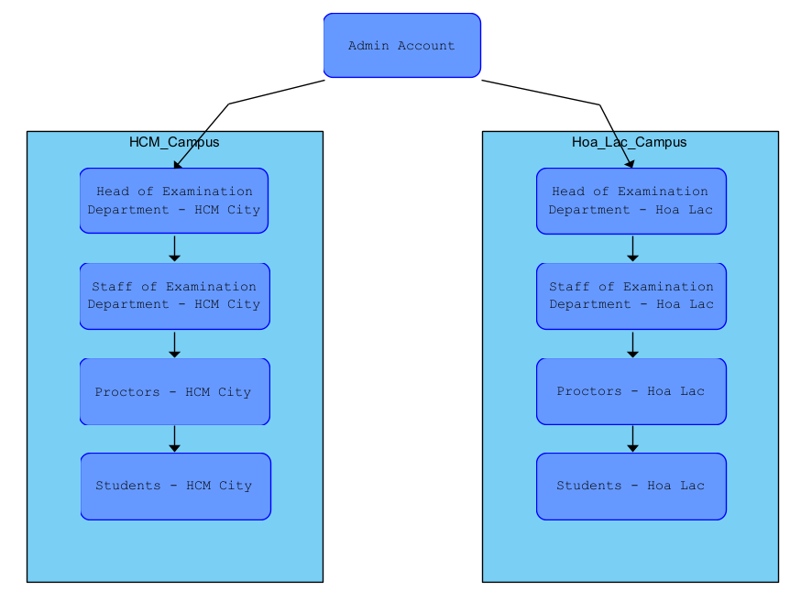

From this structure, the type of user with the largest number is likely the "Students." This is because each campus serves a large student body, and they represent the primary users of the FUE360 website for performing actions like check-in and check-out for exams.

Q3:

Q4:

| UC ID and Name: | UC - 1 Add Exam Slot | | |
| --- | --- | --- | --- |
| Created By: | HuyTXHE180649 | Date Created: | 03/04/2025 |
| Primary Actor: | Admin, Head of Examination Department | Secondary Actors: | Staff of Examination Department |
| Trigger: | * The Admin or Head of Examination Department initiates the process to add a new exam slot. * The system validates input data and saves the new slot to the database. | | |
| Description: | This use case describes the process for adding a new exam slot to the FU Exam360 (FUE360) system. | | |
| Preconditions: | 1. The user must be logged into the system with an Admin or Head of Examination Department account. 2. The user must have permission to manage exam slots. | | |
| Post conditions: | 1. The exam slot is successfully added and stored in the system. 2. The slot is made visible to all authorized users, including staff and proctors. 3. A confirmation message is shown to the user. | | |
| Normal Flow: | 1. The Admin/Head of Examination Department logs into FUE360. 2. The user navigates to the "Exam Slot Management" section. 3. The user selects the option to "Add Exam Slot." 4. The system displays a form requiring details such as:  * Exam date and time * Course name and code * Exam room and capacity * Assigned proctors  1. The user fills in the required details and submits the form. 2. The system validates the input and checks for conflicts with existing exam slots. 3. If validation passes, the system saves the new exam slot to the database. 4. A success message is displayed, and relevant staff are notified. | | |
| Alternative Flows: | 1. If the user enters incomplete or invalid data, the system displays an error message and requests corrections. 2. If the selected time slot conflicts with an existing exam, the system prompts the user to choose a different time. 3. If the user cancels the process before submission, no changes are made to the system. | | |
| Exceptions: | 1. If the system encounters a database error, the exam slot is not saved, and an error message is displayed. 2. If the user session expires, they are redirected to the login page. 3. If the internet connection is lost during submission, the system prompts the user to retry. 4. If unauthorized users attempt to access this function, the system denies access and logs the attempt. | | |
| Priority: | High | | |
| Frequency of Use: | High | | |
| Business Rules: | * Only Admins and Heads of Examination Departments can add exam slots. * Exam slots must not overlap in the same room. * Exam slots must be created before a specified deadline. | | |
| Other Information: | * The system should provide an intuitive UI for adding exam slots. * Notifications should be sent to relevant stakeholders upon successful slot creation. | | |
| Assumptions: | * The system has a predefined set of exam rooms and proctors available. * Users follow proper protocols when scheduling exams. * Data integrity is maintained in the database. | | |

**Q5:**

a. Performance Requirements

- The FUE360 system must be able to handle at least 10,000 concurrent users accessing the platform during peak exam periods without any noticeable delay (response time must be under 2 seconds for 95% of requests).

- The system must process and confirm a check-in/check-out request within 1 second after submission to ensure smooth operations for students and staff.

b. Security Requirements

- Only users with an @fpt.edu.vn email can log in to the system, and all authentication processes must

- All exam-related data, including exam slots and student check-in/out records, must be encrypted using AES-256 both in transit and at rest to prevent unauthorized access